**Lab Report 3**

**MATLAB Image Processing**

**Digital Image Processing**

**CSE438**

**Section:** 03

**Semester:** Spring-2025

**Submitted To:**

**Md. Asif Khan Rifat**

**Lecturer**

Department of Computer Science

and Engineering

**Submitted By:**

                                                                         Suddip Paul Arnab

**2022-1-60-356**

**Date of submission:** 20 March 2025

1. Apply salt and pepper noise to the following image and remove the noise using min and max filtering technique. Show input and output side by side.

img = imread("Picture1.jpg");

gray_img = im2gray(img);

noisy_img = imnoise(gray_img, 'salt & pepper', 0.05);

se = ones(3,3);

min_filtered_img = ordfilt2(noisy_img, 1, se);

max_filtered_img = ordfilt2(noisy_img, 9, se);

figure;

subplot(2,3,1), imshow(gray_img), title('Original Image');

subplot(2,3,2), imshow(noisy_img), title('Salt & Pepper Noisy Image');

subplot(2,3,3), imshow(min_filtered_img), title('Min Filtered Image');

subplot(2,3,4), imshow(max_filtered_img), title('Max Filtered Image');

1. Apply Gaussian noise to the following image and remove the noise using Gaussian filtering. Show input and output side by side.

img = imread("Picture2.jpg");

gray_img = im2gray(img);

noisy_img = imnoise(gray_img, 'gaussian', 0, 0.01);

gaussian_filter = fspecial('gaussian', [3,3], 0.5);

filtered_img = imfilter(noisy_img, gaussian_filter, 'same');

figure;

subplot(1,3,1), imshow(gray_img), title('Original Image');

subplot(1,3,2), imshow(noisy_img), title('Gaussian Noisy Image');

subplot(1,3,3), imshow(filtered_img), title('Gaussian Filtered Image');

1. Apply any noise to the following image and restore it using:
2. Box filtering
3. Average filtering
4. Median filtering

Show input and output side by side. Also show the comparison between the 3 techniques. Mention which method works better than others.

img = imread("Picture3.jpg");

gray_img = im2gray(img);

noisy_img = imnoise(gray_img, 'gaussian', 0, 0.02);

box_filter = fspecial('average', [3,3]);

box_filtered_img = imfilter(noisy_img, box_filter, 'same');

average_filter = fspecial('average', [5,5]);

average_filtered_img = imfilter(noisy_img, average_filter, 'same');

median_filtered_img = medfilt2(noisy_img, [3,3]);

figure;

subplot(2,3,1), imshow(gray_img), title('Original Image');

subplot(2,3,2), imshow(noisy_img), title('Noisy Image (Gaussian)');

subplot(2,3,3), imshow(box_filtered_img), title('Box Filtered Image');

subplot(2,3,4), imshow(average_filtered_img), title('Average Filtered Image');

subplot(2,3,5), imshow(median_filtered_img), title('Median Filtered Image');

4. Using the following image, solve questions a - f.

1. Read and show the image.
2. Show the matrix form of the image.
3. Show the pixel information by hovering the cursor on the image.
4. Find the value of the pixel (10, 78).
5. Show the size of the image.
6. Show the all the information of the image.

img = imread("Picture4.jpg");

figure, imshow(img), title('Displayed Image');

disp('Matrix form of the image:');

disp(img);

impixelinfo;

row = 10; col = 78;

pixel_value = img(row, col, :);

disp(['Pixel value at (10,78): ', num2str(pixel_value(:)')]);

image_size = size(img);

disp(['Image Size: ', num2str(image_size)]);

imfinfo_details = imfinfo("Picture4.jpg");

disp('All image information:');

disp(imfinfo_details);

5. Using the following images, solve questions a - i.

* 1. Read and show all three types of images (RGB, Grayscale, and Indexed).

rgb_img = imread('Picture5.png');

gray_img = imread('Picture6.jpg');

ind_img = imread('Picture7.jpg');

[indexed_img, colormap] = rgb2ind(ind_img, 256);

figure;

subplot(2,2,1); imshow(rgb_img); title('RGB Image');

subplot(2,2,2); imshow(gray_img); title('Grayscale Image');

subplot(2,2,3); imshow(indexed_img, colormap); title('Indexed Image');

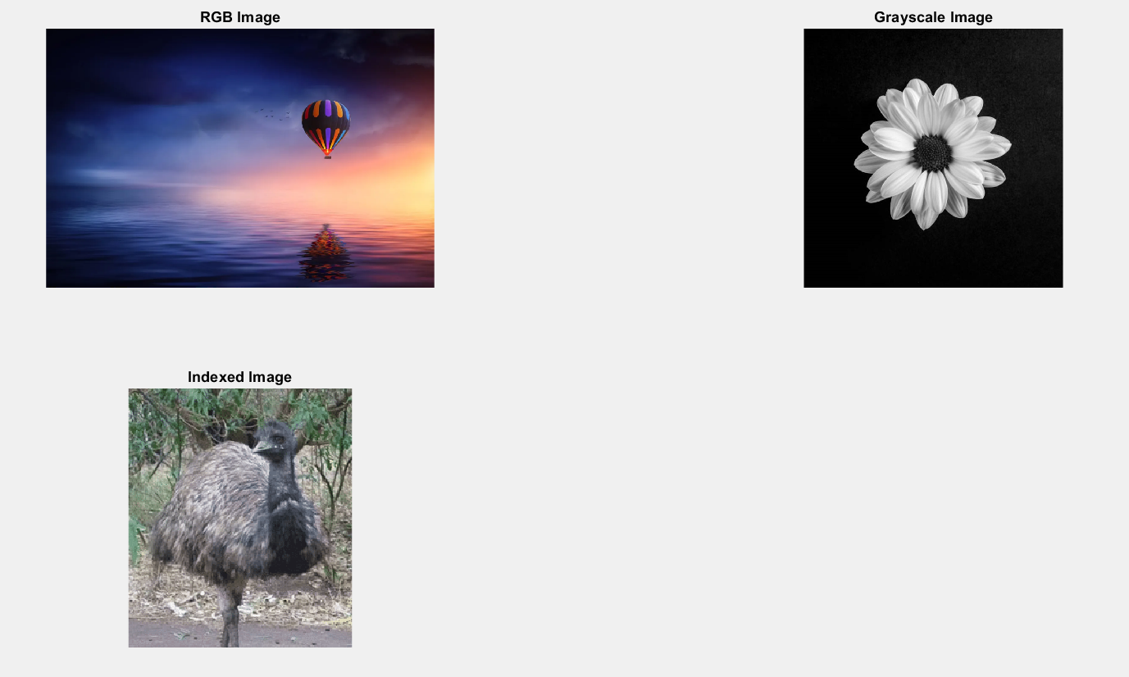

* 1. Turn the RGB image to Grayscale image.

gray_from_rgb = rgb2gray(rgb_img);

figure;

imshow(gray_from_rgb);

subplot(1,2,1); imshow(rgb_img);title('Indexed Image');

subplot(1,2,2); imshow(gray_from_rgb);title('RGB image to Grayscale image');

* 1. Turn the Indexed image to Grayscale image.

gray_from_indexed = ind2gray(indexed_img, colormap);

figure;

imshow(gray_from_indexed);

subplot(1,2,1); imshow(indexed_img, colormap);title('Indexed Image');

subplot(1,2,2); imshow(gray_from_indexed);title('Indexed image to Grayscale image.');

* 1. Turn the Indexed image to RGB image.

rgb_from_indexed = ind2rgb(indexed_img, colormap);

figure;

imshow(rgb_from_indexed);

subplot(1,2,1); imshow(indexed_img, colormap);title('Indexed Image');

subplot(1,2,2); imshow(rgb_from_indexed);title('RGB Image from Indexed');

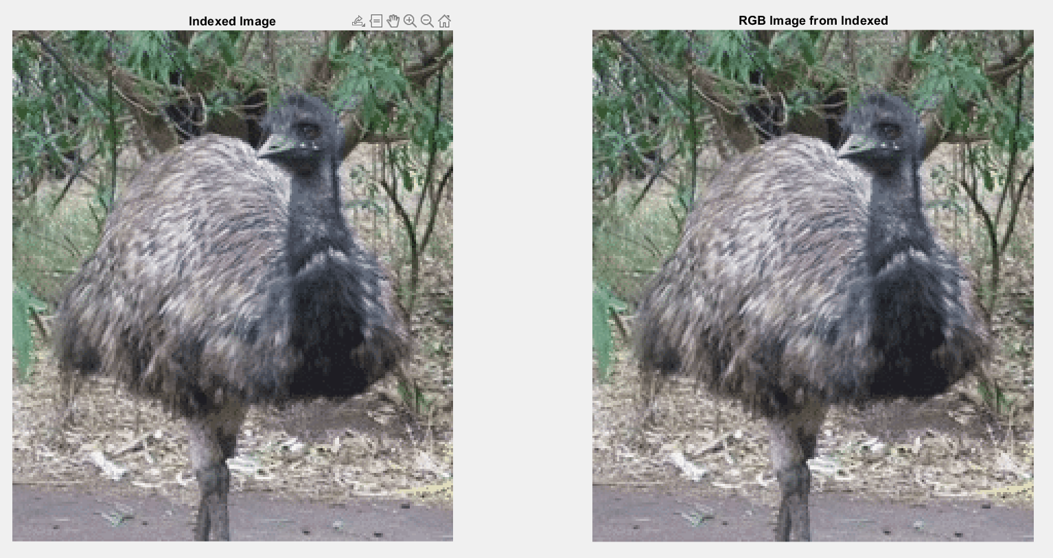

* 1. Convert the Grayscale image to a Binary image.

color_img = imread('Picture6.jpg');

if ndims(color_img) == 3

gray_img = rgb2gray(color_img);

else

gray_img = color_img;

end

binary_img = imbinarize(gray_img, 0.5);

figure;

subplot(1,2,1); imshow(gray_img); title('Grayscale Image');

subplot(1,2,2); imshow(binary_img); title('Grayscale image to a Binary image.');

* 1. Show the inverted form of that Binary image.

inverted_binary_img = imcomplement(binary_img);

figure;

imshow(inverted_binary_img);

subplot(1,2,1); imshow(binary_img); title('Binary image.');

subplot(1,2,2); imshow(inverted_binary_img);title('Inverted Binary Image');

* 1. Show the histogram of the Grayscale image.

figure;

subplot(1,2,1); imshow(gray_img); title('Gray image.');

subplot(1,2,2); imhist(gray_img);title('Histogram of the Grayscale Image');

* 1. Invert the RGB image.

inverted_rgb_img = imcomplement(rgb_img);

figure;

imshow(inverted_rgb_img);

subplot(1,2,1); imshow(rgb_img); title('RGB image.');

subplot(1,2,2); imshow(inverted_rgb_img);title('Inverted RGB Image');

* 1. Blur the RGB image.

h = fspecial('average', [3 3]);

blurred_rgb_img = imfilter(rgb_img, h);

figure;

imshow(blurred_rgb_img);

subplot(1,2,1); imshow(rgb_img); title('RGB image.');

subplot(1,2,2); imshow(blurred_rgb_img);title('Blurred RGB Image');

